CSD3156 Mobile and Cloud Computing — Team Project Report
Course: CSD3156 Mobile and Cloud Computing, Spring 2026
Team ID: [14]
Deadline: 24 February 2026
Name | SIT Student ID
Bryan Ang Wei Ze | 2301397
Tham Kang Ting | 2301255
Chew Bangxin Steven | 2303348
Sam Tsang | 2301552
Sherman Goh Wee Hao | 2301472

Links
Resource | URL
GitHub Repository | [https://github.com/gsherman01/CSD3156-Android-App ]{request to join}
App Demo Video | [CSD3156_id14_TinyCell_VideoDemo.mp4]  {Need SiT account logged in}
Presentation Video | [CSD3156_id14_TinyCell_Presentation.mp4]  {Need SiT account logged in}

Table of Contents
- Application Overview
- Design & Use Cases
- Software Architecture
- Implementation Details
- Mobile Features
- Database Design
- Firebase & Cloud Integration
- UI/UX Design
- Third-Party Libraries
- Software Engineering Practices
- Results & Evaluation
- AI Usage Declaration

How To Read OVERVIEW
The suggested area to look first would be:

First, Section 2.3 then Section 4.4 & 4.6:
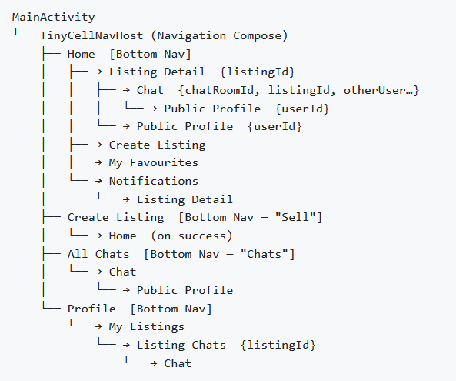
This is to show what we have done,
At the Home Screen,you can see the listings on TinySell,
Able to navigate to your Create listing, Chat, Profile, Notifications and Favourites.
Then in the Listing, you can Chat, then you can make Offer, then can leave Review when done.
For the Implementation Section.
You are able to see tentatively the logic behind the Offer, Search/Filter.
For Offer, Buyer can send multiple offers and Seller can choose to accept/reject.
If accept, they can leave a review after that.
For Search/Filter, you can search via Categories or Listing Titles , then filter can be based off price/date.
Second, Section 5
Section 5 talks about what Technical(+ Android) Features that we successfully implemented
Able to have a local database, Camera hardware, threading, Networking and Cloud Storage.
Third, Section 2
Then Section 2 to know what kind of App we have created.

Regarding the user flow/usage.
//So probably in our app video demo, we can show how users can create listings and chat with sellers to get other listings.
And then we are able to see our favorites, profiles and reviews.

What did I feel like we achieved with our app:

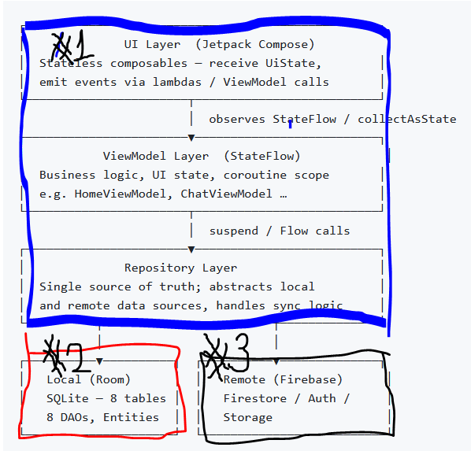

Technical Features Implemented
The project integrates multiple Android capabilities:

1. MVVM Architecture
- ViewModel
- Repository pattern
- Clean separation of concerns

2. Local Database
- Room database
- DAO-based query structure
- Reactive flows

3. Cloud Integration
- Firebase Firestore
- Firebase Storage
- Multi-device synchronization

4. Networking & Threading
- Coroutines
- Background sync
- Real-time listeners

5. Hardware Usage
- Camera integration for listing images

Results/Evaluation
+Rationale of architecture/choices [Technical & Implementation]
The final system successfully implements a complete marketplace transaction loop:
Browse → Chat → Offer → Review
We achieved:
-Multi-user synchronization
-Persistent local storage
-Reactive UI updates
-Real-time chat functionality
The application resembles a simplified but functionally complete marketplace platform.

Reflection & Critical Evaluation
This project expanded beyond initial expectations.
Initially, we focused on:
- Compose UI
- Basic ViewModel structure
The architecture naturally evolved into:
- Room database integration
- Real-time chat system
- Firebase cloud synchronization
Following feedback, we realized that:
- Listings and chat alone do not complete a user lifecycle.
- A transaction model (Offer → Review) was necessary.
This led to the implementation of:
- Offer system
- Favourites
- Profile system

Architectural Rationale
We adopted MVVM because:
- Clear separation of UI and business logic
- Scalable data flow
- Compatibility with Room and Firebase
Local-first architecture was chosen because:
- Improved responsiveness
- Offline capability
- Clear single source of truth (Room)
Firebase was integrated to:
- Enable multi-user usage
- Sync across devices
- Support real-time chat
We decided not to do:
- more specific Account Login
- experimenting with Google Lens for the Camera + Create Listing.
- Within the Listing, at the back-end, each listing would compose meta data for a more SEO way of searching/filtering.
- Some auto complete/reply functionality so it ease the buyer/seller to communicate objectively what they want from the deal/transaction.

How we made it interesting to use. [Design]
The interest comes in as it is a close-enough experience to Carousell where you can make a bunch of transactions with various listings and you can favourite and give reviews.

Design Philosophy
The goal was not feature density but system completeness.
We aimed to:
- Replicate a realistic marketplace flow
- Provide transactional clarity
- Ensure reactive UI responsiveness
- Maintain clean architectural boundaries
The in-app notification system and bottom navigation were implemented to enhance usability and modern Android interaction patterns.

Work allocation/Time Line
AI tools were used at the following stages of the project:
Stage | Tool + Who did it | Description
[Week1]  Creation of project | ChatGPT  Idea generation | prompt :  If i were to build a carousell , singapore app, how would it be scoped to fit into these deliverables and a realistic scope and taskings. For about 5 man team
Importing of libraries/API to reduce integration problem with features |  | Prompt:  “If I were to use android studios to make me this carousell app off of this project scope, how should I prompt it to have a good working project that we can add onto it. eliminating alot of the brunt work. let me know if you know more context”
Creation of Master Prompt and Context and Rules  (Prompt Engineering) | ChatGpt  (to Migrate to Gemini / Claude) | How can I configure my GenAI to sync up my other teammates AI to work on this project.  What saved action prompts , rules and master context should I have.
[Week2]  Work on Architecture of MVVM | Sherman | Imported Room. Entity, Dao, VM , Repo and then later iterate it for listings, user, chat,  Then added Retrofit, CameraX and Stateflow/coroutine capabilities
Added Simple Room Database capabilities | Kang Ting | Populate with Listing Details so we can see sample listings on the Screen.
Listing Screen to have cards for the Listing | Bryan | Helped to make the UI jetpack compose interface to be like carousell as the I was working on the back end.
“Create Listing” feature | Sherman | Require to create a Screen that have place holder for Camera feature and input fields for the Listing details.
[Week 2 /3]  Allocating of features to teammates |  | Steven – CameraX integration  Sam - usage of SQLite and future search/filtering feature  Bryan - Chat function and retrofit stuff  Kang Ting - additional help and tweaking.  Sherman - look in to Cloud stuff to sync things
[Week3]  Camera usage in “Create Listing” | Steven | Functionality of Camera to take a picture and saved it as a URL to be used
Search and Filter | Sam | Inclusion of Categories,  Adding sort by price/recency.  Search function searches title and description  Modified the DAO and database entities to store more data for better filtering
Chat Function | Bryan | Able to open a Chat to send messages between 2 people.
Adding in Cloud Storage Capabilities | Sherman | First have to import the library and create an account for firebase.  Then Architecture wise I need to make the dual-sync and offline-based strategy.  Then create the DTOs to match the Entity and create the rules/security stuff to link and talk to firebase.
[week 3/4]  Lots of Bugs |  | Cannot great the App to take information/data from the cloud and only reads from their local database storage.  Realise that the seach filter was using a boolean that we have not integrate “isSold” I believe.
[Week 4/5 ]  Post-Consultation with Prof |  | Professor wants it to have a proper user flow so we need to add UI/UX features and not work on back end architecture stuff.  I Prompted about how to make better User interaction  So we added Account Auth/ Profile/ Favourites/ Better Chatting Flow/ Offer.
[Week 5]  Bugs with Offer system | Sherman | Had the problem as we were trying to fit it in the chat system as that was a suitable place.  However the App for other features/functionality cannot look into the Chat repo to find information about the offer.  So we have to extract/decouple the offer into its own repo and firestore thing.  However, it is buggy as the Offer’s ownership in the repos could be crossed. So we had to laxxed alot of the security rules and make it more accessible to look and write into the offering system.
[Week 5/6]  Revamp of the app look and Final Features |  | The App’s Screens were very bare bones and too simplified so I tasked Kang Ting to tweak it to be more like Carousell. This resulted in a bottom navigation and more UI buttons/visuals to help the user navigate.
Polishing of the Offer System | Sherman | The Offering did not have any buttons for the users to accept/reject the deal, So I added that functionality.
Looking at Review system | Gemini | Review Prompt + chat able to send images:  Can you create a review system,  a review would contain the amount of stars ,  user will have reviews for as a seller and as a buyer,  user can leave review after the offer is accepted , the item will be reserved instead of sold , then after seller indicate it being sold, user and seller can choose to give a review,  so we need more UI to have the stages of reserved and sold.  -also could we send images in the chat messages.  -reviews should be able to be seen in an account profile.
Added of Notifications |  | I then prompted about notification feature as I was curious after the lectures about it. I scoped it to within the app as I did not want the app to run in the background of the phone.
Generating this Report |  | "Read the PDF documents CSD3156 Team Project Details.pdf and CSD3156 Team Project Grading Criteria.pdf and the Android repository at [path]. Scan the repository and generate a comprehensive markdown report based on the architecture found while adhering to the guidelines laid out in the PDF."

1. Application Overview
TinyCell is a fully native Android peer-to-peer marketplace application, conceptually similar to Carousell. Users can browse listings, create their own listings with photos, chat in real time with buyers or sellers, make and negotiate formal price offers, manage a favourites list, and receive in-app notifications — all backed by a local Room SQLite database synchronised with Firebase Cloud Firestore.
Attribute | Value
Platform | 100% Native Android
Language | Kotlin 1.9.24
UI Framework | Jetpack Compose (Material 3)
Min SDK | 26 (Android 8.0)
Target / Compile SDK | 35
JVM Target | Java 17
Architecture Pattern | MVVM (Model-View-ViewModel)
Backend | Firebase (Auth, Firestore, Storage)
Local Database | Room 2.6.1 (SQLite)

Capability? We add here

2. Design & Use Cases

2.1 Core Concept
TinyCell provides a familiar buy-and-sell marketplace experience optimised for a mobile form factor. The design prioritises:
- Discoverability — a 2-column listing grid with search and multi-dimensional filters on the home screen.
- Trust — a seller review and star-rating system, plus a formal offer workflow so both parties have a clear record of negotiations.
- Communication — a real-time chat system supporting text, image, and embedded offer messages in a single thread per listing per pair of users.
- Awareness — an in-app notification system with unread count badges that surface events such as new offers and accepted deals.

2.2 User Roles & Use Cases
Actor | Use Case
Buyer | Browse listings, search & filter, view details, add to favourites, contact seller, make an offer, view notifications, leave review
Seller | Create listings with photos, manage own listings, view inquiries per listing, accept/reject offers, mark as sold
Both | View public profiles, chat in real time, send image messages, track notification history

2.3 Navigation Flow


3. Software Architecture

3.1 Architecture Pattern — MVVM
The application follows the Model-View-ViewModel (MVVM) pattern as recommended by the Android Jetpack guidelines, with a strict layering of concerns:
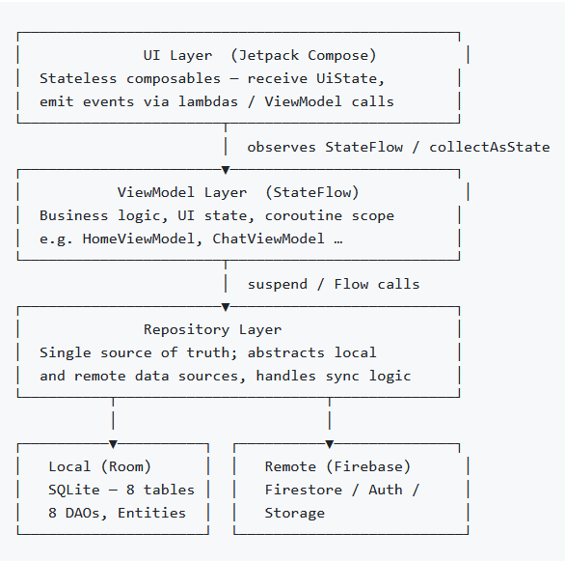

Unidirectional Data Flow:
- UI emits user intents → ViewModel → Repository → DataSource
- DataSource emits Flow<T> → Repository → ViewModel StateFlow<UiState> → UI recomposes

3.2 Project Package Structure
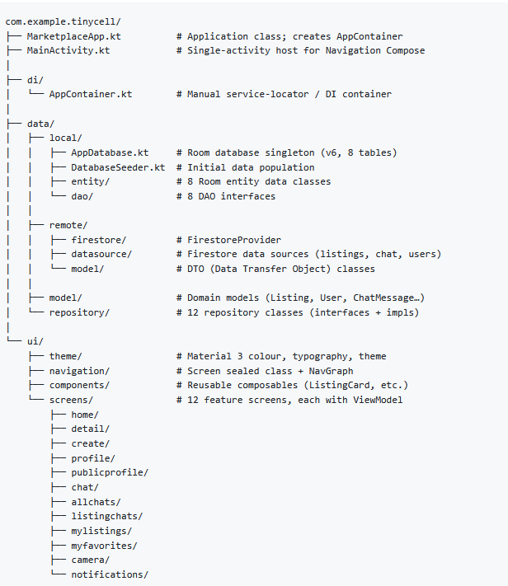

3.3 Dependency Injection (Manual DI Container)
Rather than adopting a framework such as Hilt, the team implemented a manual service-locator pattern through AppContainer. This keeps the DI visible and avoids annotation-processing overhead for a project of this scale.
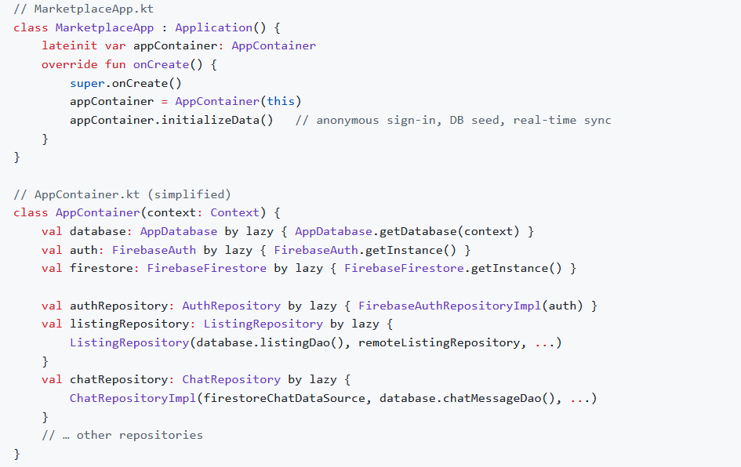

3.4 Offline-First / Dual-Write Strategy
A key architectural decision is the offline-first + real-time sync approach:
- Writes go to Room first → the UI updates immediately, even without a network connection.
- Writes are mirrored to Firestore → cloud persistence and cross-device propagation.
- Firestore snapshot listeners detect remote changes → update Room → UI recomposes automatically via Flow.
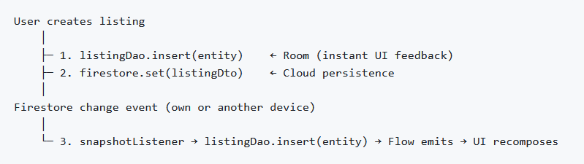

4. Implementation Details

4.1 ViewModels & UI State
Every screen has a dedicated ViewModel that exposes StateFlow<UiState> collected by the composable via collectAsState(). This ensures the UI is always driven by a single, observable source of truth and survives configuration changes.
ViewModel | Key State
HomeViewModel | listings, searchFilters, favouriteStates, unreadNotificationCount, categories, isRefreshing
ListingDetailViewModel | listing, isFavourited, favouriteCount, isLoading
CreateListingViewModel | uiState (form fields, validation, loading), selectedImages
ChatViewModel | messages, messageText, offerAmount, showOfferDialog, showReviewDialog
AllChatsViewModel | chatRooms, unreadCounts
NotificationViewModel | notifications, unreadCount
MyListingsViewModel | uiState, listings
MyFavoritesViewModel | favouriteListings
ProfileViewModel | currentUser, displayName
PublicProfileViewModel | user, listings, averageRating, reviews
CameraViewModel | hasCameraPermission, isCameraReady, cameraProvider

4.2 Repository Layer
12 repositories provide a clean abstraction over data sources:
Repository | Responsibility
ListingRepository | CRUD, search/filter, offer workflow, status transitions, notification creation
FirebaseAuthRepositoryImpl | Anonymous sign-in, display name, debug UID override
ChatRepositoryImpl | Chat room lifecycle, message send/receive, unread tracking
FavouriteRepository | Add/remove favourites, count, watchers
UserRepository | Local user CRUD
FirestoreListingRepositoryImpl | Remote listing CRUD + snapshot sync
FirebaseStorageRepositoryImpl | Multi-image upload, URL generation
FirestoreNotificationRepositoryImpl | Remote notification push/pull
CameraRepository | CameraX provider lifecycle
NetworkRepository | Network connectivity helper
RemoteListingRepository (interface) | Abstraction for remote listing ops
AppRepository | Miscellaneous app-level data

4.3 Real-Time Chat System
The chat system is one of the most complex modules. Chat rooms are identified by a deterministic, order-independent ID:
This guarantees the same room is opened regardless of who initiates the conversation. Messages support three types:
Type | Description
TEXT | Plain text message
OFFER | Embedded offer card with accept/reject actions
IMAGE | Photo message uploaded to Firebase Storage
The ChatScreen auto-scrolls to the latest message via LazyListState and marks messages read when the screen is visible. Firestore snapshot listeners keep messages in sync in real time across devices.

4.4 Offer & Negotiation Workflow
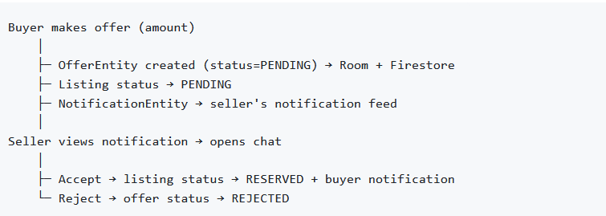

Status transitions for a listing follow: AVAILABLE → PENDING → RESERVED → SOLD.

4.5 Notification System
Notifications are generated on key events (new offer, accepted offer, price change, status change) and stored in both Room and Firestore. The HomeScreen displays a badge showing unread count:
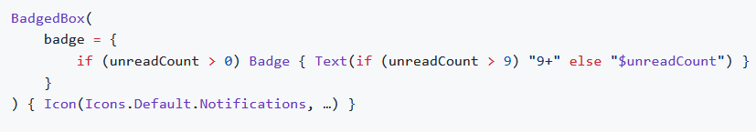

4.6 Search & Filter
The Home screen supports multi-dimensional filtering, all executed as a single Room query:
- Full-text search on title and description
- Category multi-select (Electronics, Fashion, Home, Toys, Books, General)
- Price range (min / max slider)
- Date range filter
- Active listings only (excludes sold items)

4.7 URL Encoding for Navigation Parameters
Navigation routes that carry free-text parameters (listing titles, usernames) apply URLEncoder on departure and URLDecoder on arrival to safely pass strings with spaces and special characters through the Compose Navigation back-stack.

5. Mobile Features
The application implements six of the advanced mobile features required by the course specification (minimum three required):

Feature 1 — Local Database (Room / SQLite)
Room is used as the primary offline data store with 8 tables and 8 DAOs. All queries return Flow<T> for reactive, coroutine-native streaming. The schema uses foreign keys and composite unique indices (e.g., UNIQUE(userId, listingId) on favourites).

Feature 2 — Networking (Firebase Cloud Firestore + Firebase Storage)
All user-generated content is synchronised to Google Firebase:
- Cloud Firestore stores 7 document collections and powers real-time snapshot listeners.
- Firebase Storage hosts listing and chat images, generating public download URLs.
- Retrofit + OkHttp is configured as a secondary networking layer for future REST API integration (currently initialised but ready to extend).

Feature 3 — Camera (CameraX)
CameraScreen integrates CameraX (androidx.camera 1.3.4) to provide an in-app camera preview using AndroidView with PreviewView, lifecycle binding, and photo capture. Runtime camera permission is handled via ActivityResultContracts.RequestPermission. Captured images can be attached directly to new listings.

Feature 4 — Multi-threading (Kotlin Coroutines)
All I/O operations (database queries, network calls, image uploads) run on background dispatchers via Kotlin Coroutines and are scoped to viewModelScope or lifecycleScope to prevent leaks. Flow streams propagate data reactively without blocking the main thread.

Feature 5 — Animations (Jetpack Compose)
The app uses Compose animation APIs to enhance interactivity:
- Favourite heart button animates with animateFloatAsState scale on toggle.
- Status badges use colour transitions.
- List updates leverage Compose's default recomposition diffing for smooth insertions.

Feature 6 — Multimedia / Image Handling
- Gallery multi-select via ActivityResultContracts.PickMultipleVisualMedia (up to 5 images per listing).
- Coil (io.coil-kt:coil-compose 2.5.0) loads remote images asynchronously with loading/error placeholder states.
- Image messages in chat upload directly to Firebase Storage and embed download URLs.

6. Database Design

6.1 Entity Relationship Overview
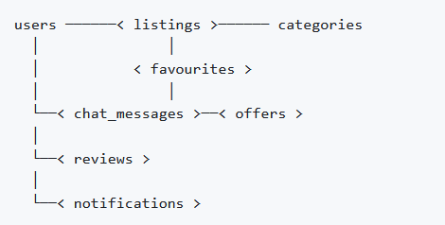

6.2 Table Schemas

users(use for profile display and auth login)
Column | Type | Constraints
id | TEXT | PRIMARY KEY
name | TEXT | NOT NULL
email | TEXT | NOT NULL
profilePicUrl | TEXT | nullable
createdAt | INTEGER | NOT NULL

listings(used to display/create listing,holds listing image too)
Column | Type | Constraints
id | TEXT | PRIMARY KEY
title | TEXT | NOT NULL
description | TEXT | NOT NULL
price | REAL | NOT NULL
userId | TEXT | FK → users.id CASCADE
sellerName | TEXT | NOT NULL
categoryId | TEXT | FK → categories.id
location | TEXT | nullable
imageUrls | TEXT | comma-separated URLs
createdAt | INTEGER | NOT NULL
isSold | INTEGER | DEFAULT 0
status | TEXT | AVAILABLE / PENDING / RESERVED / SOLD

chat_messagesoffers(used for offer feature within Chat System)
Column | Type | Constraints
id | TEXT | PRIMARY KEY
chatRoomId | TEXT | NOT NULL (indexed)
senderId | TEXT | FK → users.id CASCADE
receiverId | TEXT | FK → users.id CASCADE
listingId | TEXT | FK → listings.id CASCADE
message | TEXT | NOT NULL
timestamp | INTEGER | NOT NULL (indexed)
isRead | INTEGER | DEFAULT 0
offerId | TEXT | nullable
imageUrl | TEXT | nullable
messageType | TEXT | TEXT / OFFER / IMAGE

Offers (used for offer system , NULL,pending, accepted/rejected)
Column | Type | Constraints
id | TEXT | PRIMARY KEY
listingId | TEXT | FK → listings.id CASCADE
buyerId | TEXT | NOT NULL
sellerId | TEXT | NOT NULL
amount | REAL | NOT NULL
status | TEXT | PENDING / ACCEPTED / REJECTED
timestamp | INTEGER | NOT NULL

Favourites(storing Favourite listing system)
Column | Type | Constraints
id | INTEGER | PRIMARY KEY AUTOINCREMENT
userId | TEXT | FK → users.id CASCADE
listingId | TEXT | FK → listings.id CASCADE
createdAt | INTEGER | NOT NULL
— | — | UNIQUE(userId, listingId)

reviews(review system)
Column | Type | Constraints
id | TEXT | PRIMARY KEY
listingId | TEXT | FK → listings.id CASCADE
reviewerId | TEXT | FK → users.id CASCADE
revieweeId | TEXT | FK → users.id CASCADE
rating | INTEGER | 1–5
comment | TEXT | NOT NULL
timestamp | INTEGER | NOT NULL
role | TEXT | BUYER / SELLER

notifications(notifications for these types : xxx
OFFER_MADE / OFFER_ACCEPTED / PRICE_CHANGE / STATUS_CHANGE )

Column | Type | Constraints
id | TEXT | PRIMARY KEY
userId | TEXT | FK → users.id CASCADE (indexed)
title | TEXT | NOT NULL
message | TEXT | NOT NULL
type | TEXT | OFFER_MADE / OFFER_ACCEPTED / PRICE_CHANGE / STATUS_CHANGE
referenceId | TEXT | listingId or offerId
timestamp | INTEGER | NOT NULL (indexed)
isRead | INTEGER | DEFAULT 0

categories(repo to save how many categories there are,
They are hard coded in the code for now rather than a cloud thing)
Column | Type | Constraints
id | TEXT | PRIMARY KEY
name | TEXT | NOT NULL
icon | TEXT | nullable

7. Firebase & Cloud Integration

7.1 Firebase Services
Service | Usage
Firebase Authentication | Anonymous sign-in; UID-based user identity; display name management
Cloud Firestore | 7 collections; real-time snapshot listeners; offline persistence
Firebase Storage | Listing image hosting; chat image upload; public download URL generation

7.2 Firestore Collections
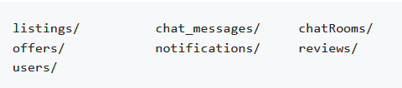

7.3 Anonymous Authentication Design
Firebase Anonymous Authentication is used so that users can participate immediately without registration friction. A user-friendly display name is derived from the last 4 hex digits of the UID:
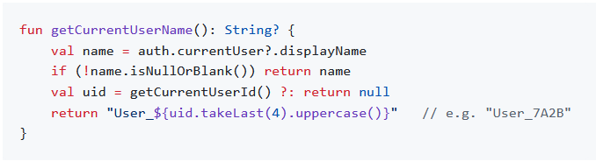

8. UI/UX Design

8.1 Design System — Material 3
The app uses the Material 3 design system (Material You) via Jetpack Compose:
- Dynamic colour theming (adapts to device wallpaper on Android 12+)
- Light and dark mode support
- Consistent typography scale
- Surface tones and elevation

8.2 Reusable Components (MarketplaceComponents.kt)
Component | Purpose
ListingCard | 2-column grid card with image, price, seller, status badge, favourite button
ListingStatusBadge | Colour-coded chip: green (Available), orange (Pending), blue (Reserved), red (Sold)
PriceTag | Formatted $X.XX price display
MessageBubble | Chat bubble with left/right alignment, timestamp, image support
SearchBar | Text field with clear and search icons
EmptyState | Icon + title + message + optional action button

8.3 Screen Inventory
Screen | Key UI Elements
Home | 2-column grid, search bar, category chips, filter panel, notification badge, FAB
Listing Detail | Image gallery, price, status badge, favourite toggle, chat CTA, related listings
Create Listing | Form fields, image picker row (up to 5), category dropdown, submit button
Profile | User info, edit name dialog, My Listings shortcut
My Listings | Grid of own listings with status, delete, and chat inquiry buttons
My Favourites | Grid of bookmarked listings with remove option
All Chats | Conversation list with last message and unread indicator
Chat | Real-time message list, text input, offer dialog, review dialog, image send
Listing Chats | Buyer inquiry list for a specific listing (seller view)
Public Profile | User's listings, average star rating, review history
Notifications | Chronological notification list, unread highlighting, mark read
Camera | CameraX preview, capture button, permission handling

9. Third-Party Libraries
All third-party libraries are listed here as required by the project specification.
Library | Version | Purpose
Jetpack Compose BOM | 2024.10.00 | Declarative UI framework
androidx.navigation:navigation-compose | 2.8.3 | Type-safe in-app navigation
androidx.lifecycle:lifecycle-viewmodel-compose | 2.8.7 | ViewModel integration with Compose
androidx.room:room-runtime / room-ktx | 2.6.1 | Local SQLite ORM
androidx.room:room-compiler (KSP) | 2.6.1 | Code generation for Room DAOs
com.google.firebase:firebase-bom | 33.3.0 | Firebase platform BOM
firebase-firestore-ktx | (BOM) | Cloud NoSQL database & real-time sync
firebase-storage-ktx | (BOM) | Cloud file storage
firebase-auth-ktx | (BOM) | User authentication (anonymous)
io.coil-kt:coil-compose | 2.5.0 | Asynchronous image loading
androidx.camera:camera-core / camera2 / camera-lifecycle / camera-view | 1.3.4 | In-app camera via CameraX
com.squareup.retrofit2:retrofit | 2.9.0 | HTTP networking client
com.squareup.retrofit2:converter-gson | 2.9.0 | JSON serialisation for Retrofit
com.squareup.okhttp3:logging-interceptor | 4.12.0 | HTTP request/response logging
org.jetbrains.kotlinx:kotlinx-coroutines-play-services | 1.7.3 | Coroutine extensions for Firebase Tasks
com.google.guava:guava | 31.1-android | Required by CameraX
androidx.compose.material:material-icons-extended | 1.7.8 | Extended Material icon set
KSP (Kotlin Symbol Processing) | 1.9.24-1.0.20 | Annotation processing for Room
Google Services plugin | 4.4.2 | Firebase project configuration

10. Software Engineering Practices

10.1 Version Control
The project is maintained in a GitHub repository with regular commits across the development period. Each feature was developed incrementally, with the build kept compilable at every commit.

10.2 Code Quality
- Kotlin coding conventions (Android style guide) are followed throughout — camelCase for functions/variables, PascalCase for classes, trailing lambdas, expression bodies where appropriate.
- Code is self-documenting with descriptive naming (e.g., generateChatRoomId, markMessagesAsRead, getUnreadNotificationCount).
- Complex logic (e.g., dual-write strategy, chat room ID generation, offer workflow) is documented with inline comments.
- No deprecated APIs are used; Jetpack Compose and CameraX are both stable-release libraries.

10.3 Modular Code Structure
The codebase is divided into well-defined layers:
- Data layer — entities, DAOs, DTOs, data sources, repositories
- Domain layer — clean model classes decoupled from persistence and UI concerns
- UI layer — screens, ViewModels, components, theme, navigation
Each screen module (home/, chat/, create/, etc.) is self-contained, grouping the composable screen file and its ViewModel together.

10.4 Coroutine & Resource Management
- All ViewModel coroutines are launched in viewModelScope and cancelled automatically on ViewModel clearance.
- Firestore snapshot listeners are stored as ListenerRegistration references and removed onCleared() to prevent memory leaks.
- SharingStarted.WhileSubscribed(5000) is used on stateIn flows to upstream flows when no collectors are active.

10.5 Error Handling
Repository methods return Result<T> (Kotlin stdlib), propagating success and failure to the ViewModel without throwing unhandled exceptions into the UI layer.

10.6 Build Configuration
- AGP 8.6.1 with KSP (replacing KAPT) for faster annotation processing.
- Firebase BOM pinned to 33.3.0 for stability with Kotlin 1.9.24.
- fallbackToDestructiveMigration() on Room is a development convenience (noted for replacement with proper migrations in production).
- Compile SDK 35 / Target SDK 35 / Min SDK 26 provides broad device coverage.

11. Results & Evaluation

11.1 Features Implemented
Feature | Status
Marketplace listing browse (grid, infinite scroll) | Complete
Multi-dimensional search & filter | Complete
Create listing with multi-image upload | Complete
In-app camera capture (CameraX) | Complete
Real-time chat (text, image, offer messages) | Complete
Formal offer workflow (make / accept / reject) | Complete
Listing status lifecycle (Available → Sold) | Complete
In-app notification system with badge | Complete
Favourites (add/remove, count, watchers) | Complete
Seller review & star-rating system | Complete
Public seller profile page | Complete
Anonymous authentication (Firebase Auth) | Complete
Offline-first local database (Room, 8 tables) | Complete
Real-time cloud sync (Firestore snapshot listeners) | Complete
Firebase Storage image hosting | Complete
Material 3 light/dark theme | Complete

11.2 Mobile Feature Checklist (Course Requirement)
Course Feature | Implementation
Database (multiple tables) | Room SQLite with 8 tables and foreign-key relationships
Networking | Firebase Firestore + Storage; Retrofit configured
Camera / Sensor | CameraX in-app camera screen
Multimedia | Multi-image gallery picker; Coil image loading; image chat messages
Animations | Compose animated favourite toggle; badge transitions
Multi-threading | Kotlin Coroutines throughout; Flow-based reactive data

11.3 Known Limitations
- The Retrofit ApiService interface is initialised but not yet wired to a REST endpoint — it is a prepared extension point.
- Location-based geo-queries are not implemented despite the location field being present on listings.
- Room is configured with destructive migration (fallbackToDestructiveMigration) which drops data on schema changes — suitable for development, but should be replaced with proper migration scripts before production release.

12. AI Usage Declaration (Located in another document)
Report generated for CSD3156 Mobile and Cloud Computing, Spring 2026

